GEOINFOTECH
ELECTION DATA CENTER
A Geospatial Voter-Intelligence & Campaign-Analytics Platform for Lagos State
Mapping voting strength from LGA to ward to polling unit — powered by PVC collection, the voter register, and the polling-unit geospatial database.
Concept & Technical Proposal
Prepared by: Geoinfotech — GIS Team
Date: 17 August 2026
Status: Concept draft · figures shown are sample/illustrative data

Contents

1. Executive Summary
The Election Data Center (EDC) is a proposed geospatial voter-intelligence platform that turns two routine but under-exploited electoral datasets — Permanent Voter Card (PVC) collection and the registered-voter register — into a live map of voting strength across Lagos State. By joining these figures to the polling-unit geospatial database, the EDC can measure, rank and visualise electoral readiness at three nested levels: the 20 Local Government Areas, the 245 wards (Registration Areas), and all 13,325 polling units.
Comparing the 2022 baseline against the 2026 cycle exposes exactly where the electorate is growing, where PVC collection is lagging, and where a campaign should concentrate mobilisation. The same engine feeds a data-mining unit that produces ward-by-ward campaign maps, target lists and priority scores for field teams. This document sets out the concept, the data model, the analytics, the mapping framework, the application architecture and a phased delivery plan.
Illustrative headline figures (built on sample data anchored to Lagos control totals of 7,060,195 registered voters, 20 LGAs, 245 wards and 13,325 polling units):
7,282,234  2026 PVCs COLLECTED (TOTAL) | 90.8%  2026 COLLECTION RATE | Alimosho  HIGHEST-STRENGTH LGA
6,168,573  2022 PVCs COLLECTED (TOTAL) | +1,113,661  NET NEW PVCs 2022→2026 | 1,068,711  HIGHEST LGA PVC COUNT

Note: every number in this document is sample/illustrative data used to demonstrate the platform. Real INEC register figures, PVC-collection returns and the official polling-unit geodatabase drop straight into the same structure without redesign.

2. The Problem & the Opportunity
Campaigns and electoral stakeholders in Lagos routinely hold the raw ingredients of voter intelligence — the register, the PVC-collection returns and the polling-unit list — but hold them as disconnected spreadsheets. Three problems follow from that:
- Numbers without geography. A PVC-collection figure for a ward means little until it sits on a map beside its neighbours and its trend since the last cycle.
- No single source of truth. LGA, ward and polling-unit figures live in separate files at separate offices, so nobody can move cleanly from the state picture down to a single polling unit.
- Reactive, not targeted, mobilisation. Without a strength score per ward, field resources are spread evenly instead of aimed at the units with the largest un-collected or newly registered voter blocks.
The opportunity is to fuse these datasets once, in one geospatial system, and keep them current. PVC collection rate — PVCs collected as a share of registered voters — becomes a direct, comparable measure of voting strength and electoral readiness at every level. Layered against the 2022 baseline, it becomes a measure of momentum. That is the core of the Election Data Center.

3. Data Foundation
The EDC is built on four data inputs, exactly as scoped for this initiative:
# | Data input | Level | Role in the platform
1 | PVCs collected (2022) & Registered Voters (2022) | LGA / Ward / PU | Baseline voting strength and collection rate
2 | PVCs collected (2026) & Registered Voters (2026) | LGA / Ward / PU | Current strength; growth & momentum vs 2022
3 | Polling-unit geospatial database (Lagos) | Point + boundary | Geometry that turns every figure into a map
4 | App + data-mining unit | Platform | Delivery layer for maps, scores & campaign targeting

Joining inputs 1–2 to input 3 is what enables mapping of voting strength at LGA, ward and polling-unit level. The join key is the polling-unit code, which rolls up cleanly into ward and then LGA, giving one consistent hierarchy from the state down to a single unit.

3.1 Data model
A single star schema keeps the hierarchy consistent:
- Geography dimension: State → LGA → Ward (Registration Area) → Polling Unit, each with its geometry (point and, where available, boundary polygon).
- Voter facts: registered voters and PVCs collected, per unit, per cycle (2022, 2026, and future cycles).
- Derived measures: collection rate (voting strength), un-collected PVC gap, cycle-on-cycle growth, and a composite campaign-priority score.

4. Analytics Engine & Key Metrics
The analytics engine computes a consistent set of measures at every level. The two headline campaign metrics you asked for — the highest number of PVCs collected and the total number of PVCs collected — fall out directly, and can be sliced by LGA, ward or polling unit.

4.1 Core metrics
- Total PVCs collected — the sum of PVCs collected across the selected area and cycle. Sample statewide 2026: 7,282,234 PVCs (2022: 6,168,573).
- Highest PVCs collected — the top-ranked unit at each level. Sample 2026: LGA Alimosho (1,068,711); ward Alimosho Ward 05 (87,634); polling unit OJO/03/001 (1,548).
- Collection rate / voting strength — PVCs collected ÷ registered voters. Sample statewide: 90.8% (2026) vs 87.4% (2022).
- Un-collected PVC gap — registered voters minus PVCs collected; the direct mobilisation target.
- Momentum (2022 → 2026) — net new PVCs and rate change per unit, flagging surging and declining areas.

4.2 Sample statewide picture
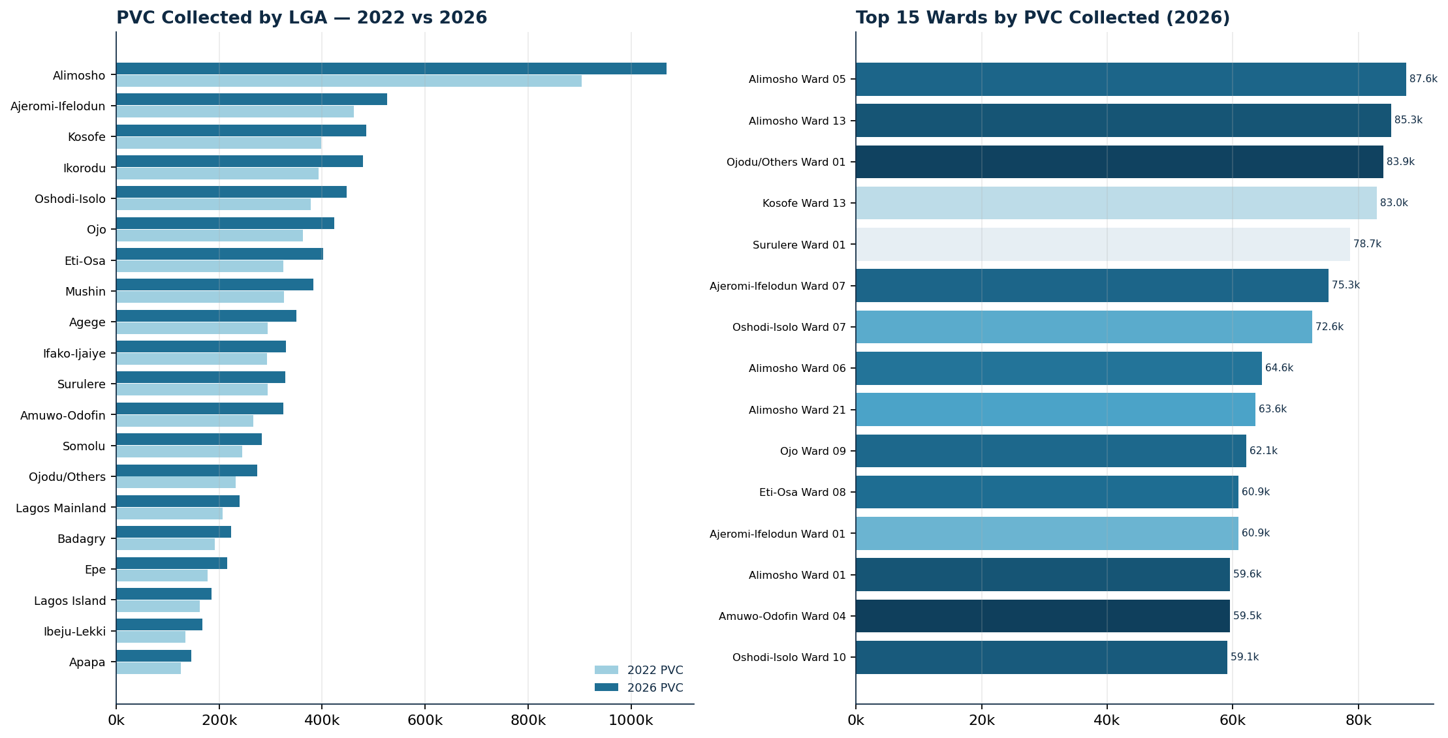
PVC collected by LGA (2022 vs 2026) and the top 15 wards by 2026 collection — sample data.

4.3 Top LGAs by voting strength (sample)
LGA | Registered 2026 | PVC collected 2026 | Rate | Net new vs 2022
Alimosho | 1,151,401 | 1,068,711 | 92.8% | +164,083
Ajeromi-Ifelodun | 567,720 | 525,645 | 92.6% | +64,000
Kosofe | 554,600 | 485,870 | 87.6% | +88,108
Ikorodu | 533,362 | 479,760 | 90.0% | +86,318
Oshodi-Isolo | 487,920 | 447,746 | 91.8% | +70,336
Ojo | 461,700 | 423,657 | 91.8% | +60,452
Eti-Osa | 438,960 | 401,432 | 91.5% | +77,412
Mushin | 423,360 | 382,619 | 90.4% | +57,115
Agege | 378,479 | 350,317 | 92.6% | +56,107
Ifako-Ijaiye | 362,518 | 329,845 | 91.0% | +37,028

5. Geospatial Mapping Framework
Every metric is rendered on a map at the level the user selects. The framework is a classic drill-down: start at the state, click into an LGA, then a ward, then a polling unit — the figures re-aggregate at each step.
Level | Units | Primary map | Campaign use
State → LGA | 20 LGAs | Choropleth / graduated bubbles | Where the big blocks and gaps are
LGA → Ward | 245 wards | Ward tiles by voting strength | Assign field teams; set priorities
Ward → Polling Unit | 13,325 PUs | Point map / heat map | Micro-targeting & agent deployment

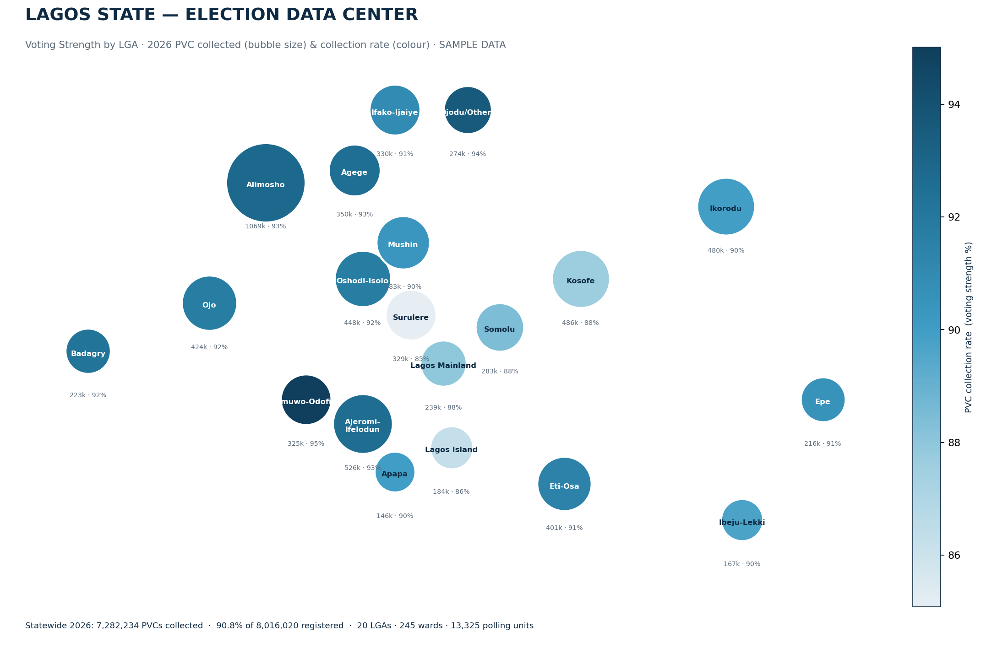
Statewide voting-strength map — bubble size = PVCs collected, colour = collection rate (sample data).
Colour encodes voting strength (collection rate) on a single sequential ramp, so light-to-dark reads consistently at every level. Size, where used, encodes the absolute PVC count — separating "how strong" from "how big", the two questions a campaign always asks together.

6. Ward Campaign Maps
The platform generates a campaign map for every ward in Lagos. Each ward is rendered as a card carrying its PVC count, collection rate, polling-unit count and a campaign-priority tag derived from its strength relative to the state:
- HIGH priority — low collection / large un-collected block: the biggest mobilisation upside.
- MEDIUM priority — mid-range strength; hold and consolidate.
- WATCH — already strong; protect turnout, guard against complacency.
These are compiled into a Ward Campaign Map Pack — one page per LGA, every one of the 245 wards tiled and colour-coded — delivered alongside this proposal as a companion PDF. It is regenerated automatically each time new PVC returns are loaded, so field teams always work from the current picture.
The accompanying pack, Ward_Campaign_Map_Pack.pdf, contains the full set of ward campaign maps for all 20 LGAs.

7. Application & System Architecture
The EDC is delivered as a web application over a geospatial database, so any authorised user can move from the state map to a single polling unit in a few clicks, on desktop or in the field.

7.1 Layers
- Data layer: PostgreSQL + PostGIS holding the geography hierarchy and voter facts; INEC register, PVC returns and the polling-unit geodatabase load through a validated ETL pipeline.
- Analytics layer: scheduled jobs compute collection rate, gaps, momentum and the priority score, and materialise them per level for fast maps.
- Map & API layer: a tile/feature service (e.g. GeoServer / Mapbox GL) serves LGA, ward and PU layers to the front end.
- Application layer: an interactive dashboard — drill-down maps, KPI tiles (total & highest PVC), 2022-vs-2026 toggle, filters and one-click export of ward map packs and target lists.
- Data-mining / campaign layer: the targeting workspace described in Section 8.

7.2 Access & roles
Role-based access separates a read-only strategist view from an analyst/editor view and an administrator. All access is logged, and datasets are versioned by cycle so results are always reproducible and auditable.

8. Data-Mining Unit for Campaigns
Sitting on top of the analytics engine, the data-mining unit converts the maps into action for a campaign. It is the operational arm of the EDC.
- Priority scoring: ranks all 245 wards (and every polling unit) by mobilisation upside, combining un-collected PVC gap, registration growth and turnout history.
- Target lists: exports the top-N wards or polling units per LGA, with counts and contacts, straight to field coordinators.
- Segmentation: clusters wards by profile — high-growth, low-collection, swing, stronghold — so messaging and resourcing match the terrain.
- Scenario & tracking: models "what if collection rises X points in these wards", then tracks actual PVC returns against the plan cycle to cycle.
- Alerts: flags wards where collection stalls or a large registered block remains un-carded, so effort is redirected in-cycle.
Because the unit reads from the same single source of truth as the maps, the target list a coordinator receives and the map a strategist sees are always the same numbers — no reconciliation, no stale spreadsheets.

9. Implementation Roadmap
Delivery is phased so a usable product appears early and capability compounds.
Phase | Focus | Key deliverables | Indicative timeline
1 | Data foundation | ETL for register, PVC returns & polling-unit geodatabase; PostGIS schema; data validation | Weeks 1–4
2 | Analytics & maps | Collection-rate & gap metrics; LGA/ward/PU maps; total & highest PVC KPIs | Weeks 4–8
3 | Application | Interactive drill-down dashboard; 2022-vs-2026 comparison; ward map-pack export | Weeks 8–14
4 | Data-mining unit | Priority scoring, target lists, segmentation, alerts | Weeks 12–18
5 | Rollout & training | Role-based access, field-team onboarding, live-cycle support | Weeks 16–20

Phases overlap by design: the maps from Phase 2 are usable while the full application in Phase 3 is still being built, so decision-makers get value from the data well before the platform is feature-complete.

10. Governance, Data Integrity & Ethics
- Source of truth: only official INEC register, PVC-collection returns and the recognised polling-unit geodatabase are loaded; every dataset is dated and versioned by cycle.
- Aggregation, not surveillance: the platform works with counts and rates at unit level, not personal voter records — it measures collection and strength, it does not profile individuals.
- Security: encrypted storage, role-based access and full audit logging of who viewed or exported what.
- Transparency & reproducibility: every figure traces back to a loaded, dated source, so any map or ranking can be reproduced and defended.
- Lawful, ethical use: the EDC supports legitimate voter mobilisation and electoral planning in line with electoral law and data-protection norms.

11. Next Steps
- Confirm data access — obtain the 2022 & 2026 register and PVC-collection returns and the Lagos polling-unit geodatabase.
- Load & validate — run the real data through the schema to replace the sample figures in this document.
- Stand up the pilot — deliver the statewide map, ward map pack and KPI dashboard for one senatorial district first.
- Scope the data-mining unit — agree the priority-score weighting and target-list formats with the campaign team.
On approval, work begins with Phase 1. The sample maps and figures in this document — and the companion ward map pack — show exactly what the finished platform produces the moment real data is loaded.
Geoinfotech — GIS Team · Election Data Center concept proposal · All figures sample/illustrative pending real INEC & geodatabase load.

